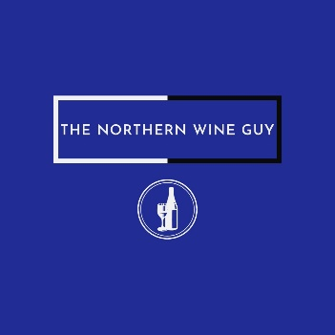
TERMS OF USE
These terms of use apply to the following website: www.thenorthernwineguy.co.uk (the “Website”).
By using the Website, you confirm that you accept these terms of use and that you agree to comply with them. If you do not agree to these terms of use, you must not use the Website. We recommend that you print or save a copy of these terms of use for your future reference.
These terms of use should be read in conjunction with our Privacy Policy.
These terms of use do not apply to any products or services that are described on the Website. Terms relating to our products and services will be provided as necessary.
The Website is operated by The Northern Wine Guy. To contact us, please email us at andrew@thenorthernwineguy.co.uk
We amend these terms from time to time. The latest and most up to date Terms of Use is always available on our website for you to refer to so that you understand the terms that apply at any time.
We may update and change the Website from time to time to reflect changes to our service offering, our users’ needs and our business priorities.
We do not guarantee that the Website, or any content on it, will always be available or be uninterrupted. We may suspend or withdraw or restrict the availability of all or any part of the Website for business and operational reasons. We will try to give you reasonable notice of any suspension or withdrawl.
You are also responsible for ensuring that all persons who access the Website through your internet connection are aware of these terms of use and other applicable terms and conditions, and that they comply with them.
We are the owner of all intellectual property rights on the Website, and in the material published within it. These works are protected by laws and treaties and all such rights are reserved.
You must not modify any materials you have printed off or downloaded in anyway, and you must not use any illustrations, photographs, video or audio sequences or any graphics separately from any accompanying text. You must not use any part of the content on the Website for commercial purposes without obtaining a license to do so from us.
The content on the Website is provided for general information only. It is not intended to amount to advice on which you should rely. You must obtain professional or specialist advice before taking, or refraining from, any action on the basis of the content on the Website.
Although we make reasonable efforts to update the information on the Website, we make no representations, warranties or guarantees, whether express or implied, that the content on the Website is accurate, complete or upto date.
Where the website contains links to other sites and resources provided by third parties, these links are provided for your information only. Such links should not be interpreted as approval by us of those linked websites or information you may obtain from them. We have no control over the contents of those sites or resources.
Please note that we only provide the Website for domestic and private use. You agree not to use the Website for any commercial or business purposes, and we have no liability to you for any loss of profit, loss of business, business interruption, or loss of business opportunity.
We will only use your personal information as set out in our Privacy Policy.
We do not guarantee that the Website will be secure or free from bugs or viruses. You are responsible for configuring your information technology, computer programmes and platform to access the Website. You should use your own virus protection software. You must not misuse the Website by knowingly introducing viruses, trojans, worms, logic bombs or other material that is malicious or technologically harmful. You must not attempt to gain unauthorised access to the Website, the server on which the Website is stored or any server, computer or database connected to the Website. You must not attack the Website via a denial-of-service attack or a distributed denial-of-service attack. By breaching this provision, you would commit a criminal offence under the Computer Misuse Act 1990. We will report any such breach to the relevant law enforcement authorities and we will co-operate with those authorities by disclosing your identity to them. In the event of such a breach, your right to use the Website will cease immediately.
If you wish to link to or make any use of content on our Website other than set out above, please contact andrew@thenorthernwineguy.co.uk .
Please note that these terms of use, their subject matter and their formation, are governed by English law. You and we both agree that the courts of England and Wales will have exclusive jurisdiction.

The Northern Wine Guy.

